Information Security Recommended Training
All training is available at knowbe4.com. Use your UConn email address to sign in at the main screen and then you will be prompted for your NetID and Password.
In addition to the selected training below, KnowBe4 has a plethora of training modules surrounding data security, phishing, smishing, vishing, malware and a whole host of constantly changing security content that helps you defend against attacks both professionally and personally.

Title: 2021 Kevin Mitnick Security Awareness
Audience: All Faculty / Staff
Description: This module gives you the insider information you need to identify common techniques hackers use against you in an attempt to gain access to your organization’s valuable resources. It actually happens way more than you would think. Join Kevin Mitnick as he takes you behind the scenes to demonstrate how the bad guys do what they do. Finally, discover the warning signs of a hacker’s attack and the actions you should take to protect yourself and your organization from them.
Direct Link (must be signed into KnowBe4 first):
2021 Kevin Mitnick Security Awareness Training - 15 Minutes (knowbe4.com)
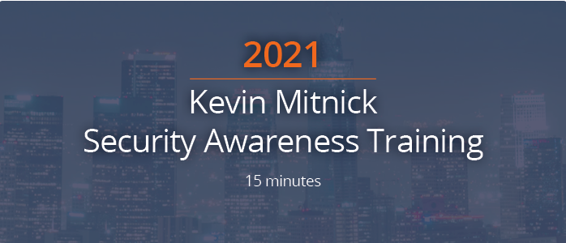

Title: Remote Work: Keeping It Private
Audience: Telecommuters
Description: This 10-minute video discusses those actions you should take to help protect both University systems as well as your own when working remotely on either a permanent or temporary basis.
Direct Link (must be signed into KnowBe4 first):
Remote Work: Keeping It Private (knowbe4.com)
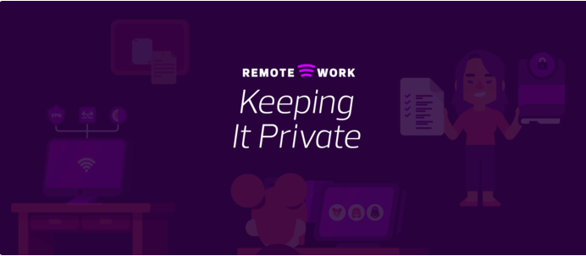

Title: The Inside Man
Audience: All Faculty/Staff
Description: {Drama} In KnowBe4’s signature video series, a compelling story, an incredible cast, and stellar production quality combine to create the coolest series ever streamed. Shy, slightly nerdy Mark is finding his way amidst super-friendly, supportive co-workers, office politics and his new job as IT Security analyst--a “white hat” hacker making the company safer. At least…that’s how it looks on the outside. No one suspects that he’s already inside their most secure systems, or that powerful forces are pulling his strings. Will he complete his mission to bring down the company? Or will these new friendships bring him out of the dark web and into the light?
Direct Link (must be signed into KnowBe4 first):
The Inside Man: Season 1 Ep 00 - Full Trailer (knowbe4.com)

Title: Restricted Intelligence
Audience: All Faculty/Staff
Description: {Comedy} Watch in disbelief as Rebecca, Gerald, Jack, Chloe, Ellie and Lionel, stagger from one data debacle to another, pausing only to leave the doors unlocked on the way out... When you’ve got a team like this, who needs hackers?
Direct Link (must be signed into KnowBe4 first):
Restricted Intelligence Season 1: Ep 00 - Teaser Trailer (knowbe4.com)

